Coding Challenge:
A retail company receives daily order files from its sales application.
The source application uploads CSV files into an Azure Storage Account.
Snowflake should automatically load the new files whenever they arrive in Azure Storage.
The company wants:
1. A separate Snowflake warehouse for loading data
2. A separate user and role for data engineering
3. Data ingestion from Azure Storage Account
4. Initial load from CSV file
5. Automatic incremental loading when new CSV files are uploaded
6. Avoid duplicate records in the final table
Important Concept for Students
Snowflake does not automatically detect new rows added inside the same old file.
Best practice is:
Do not edit the already uploaded CSV file.
Instead, upload a new CSV file for every new batch.
Example:
retail_orders_initial.csv
retail_orders_incremental_20260508.csv
retail_orders_incremental_20260509.csv
retail_orders_incremental_20260510.csv
Snowpipe detects and loads new files, not newly edited rows inside the same file.

A: Snowflake Setup
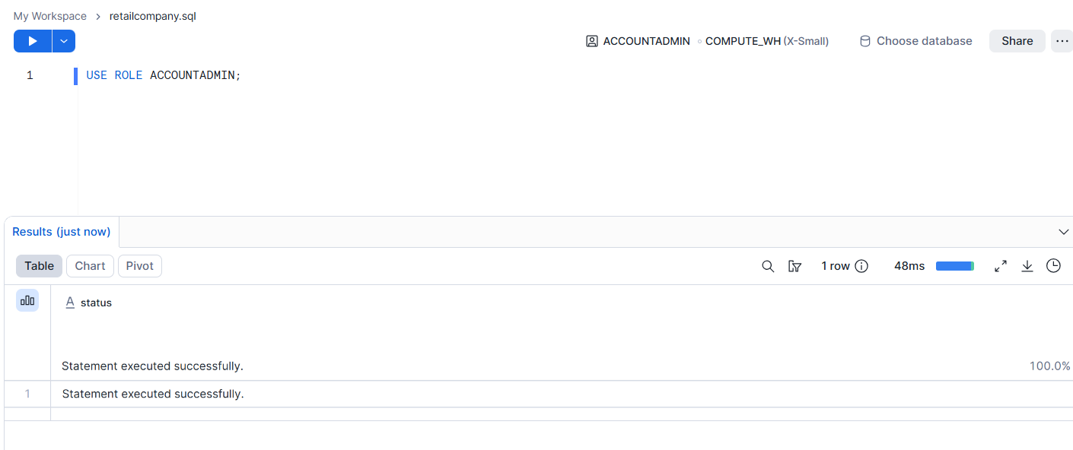

Create a database named RETAIL_DB.
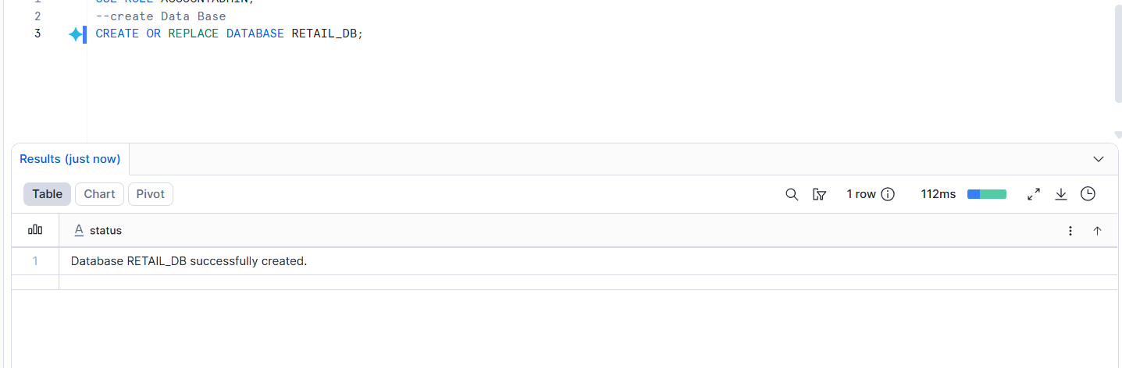
Create a schema named RETAIL_DB.ORDERS_DEMO.
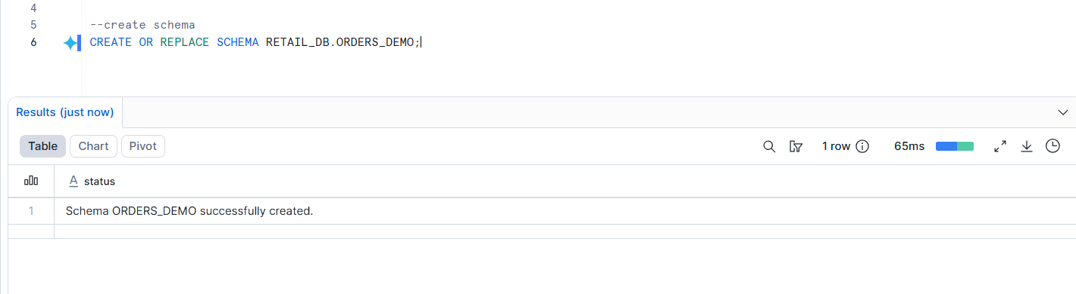
Create a warehouse named RETAIL_LOAD_WH.
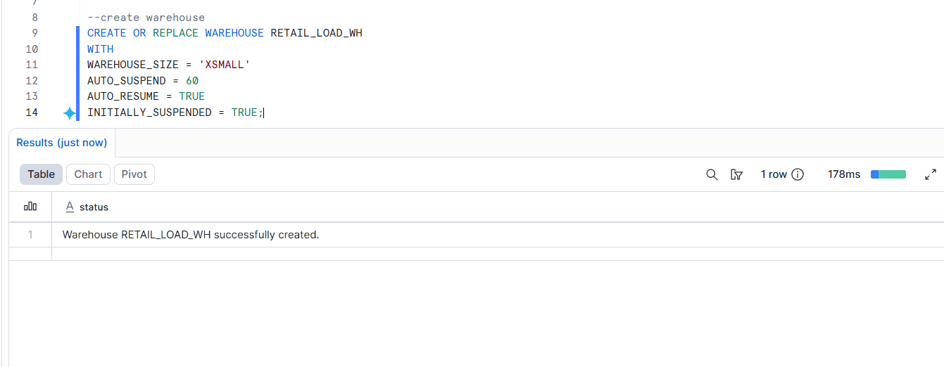
Create a role named RETAIL_DATA_ENGINEER_ROLE.
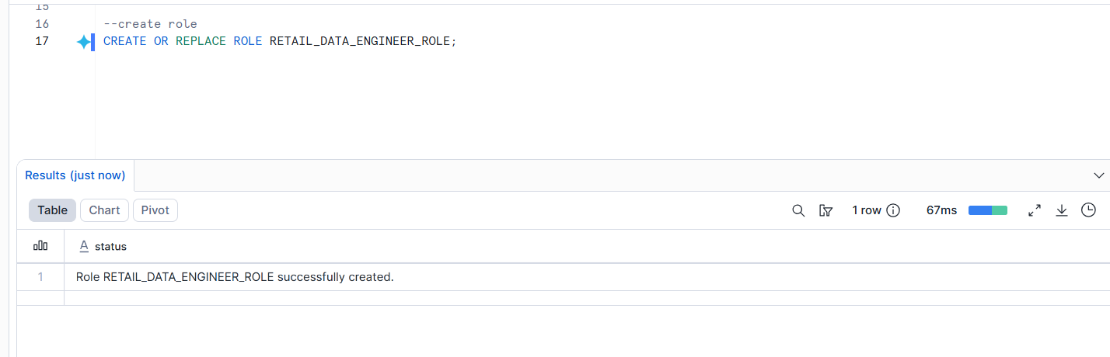
Create a user named RETAIL_ENGINEER_USER.
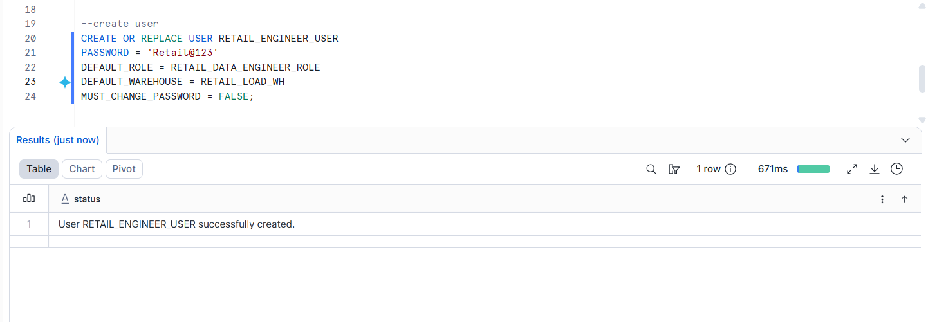
Grant required permissions to the role and user.
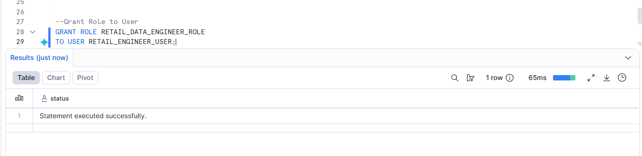
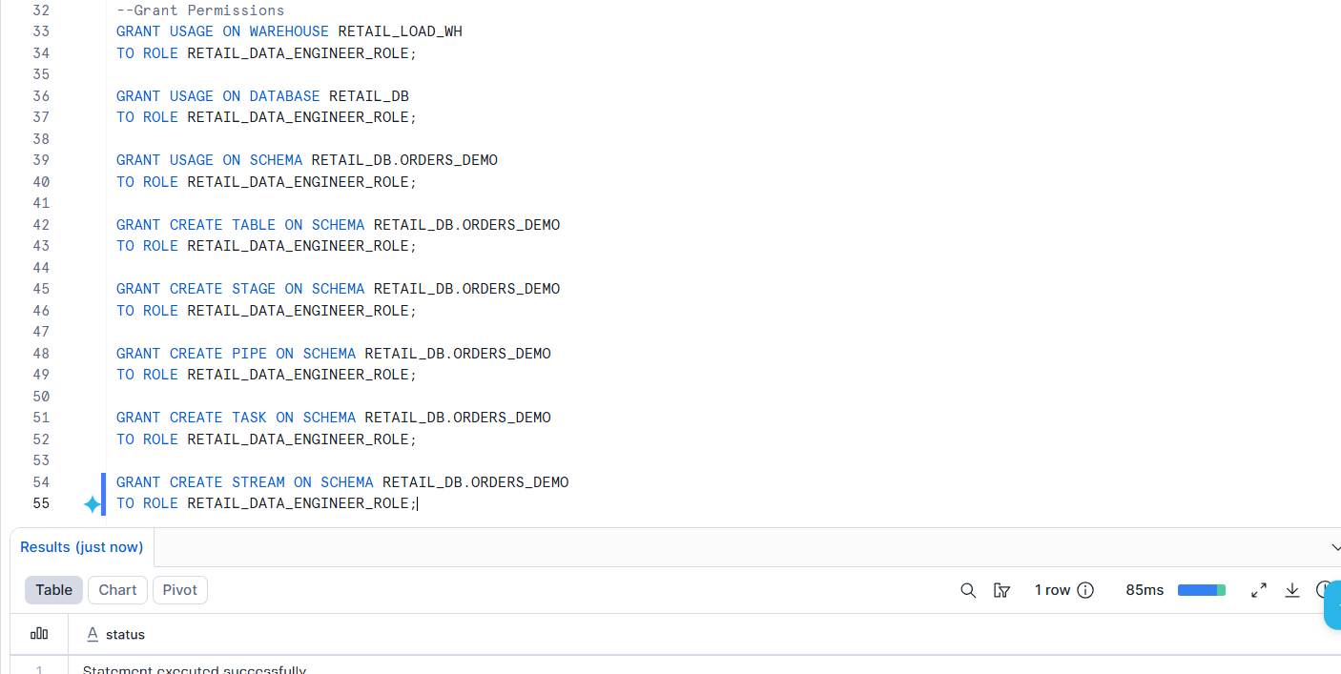

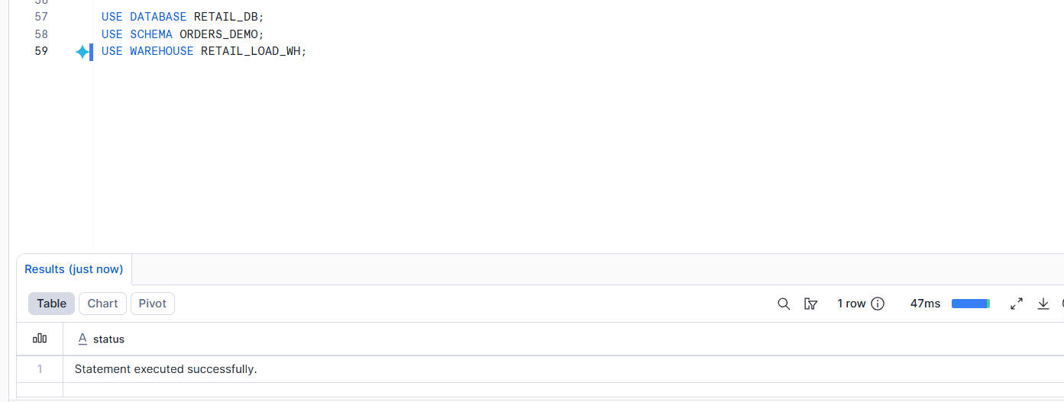
Part B: Azure Storage Setup

Create an Azure Storage Account.
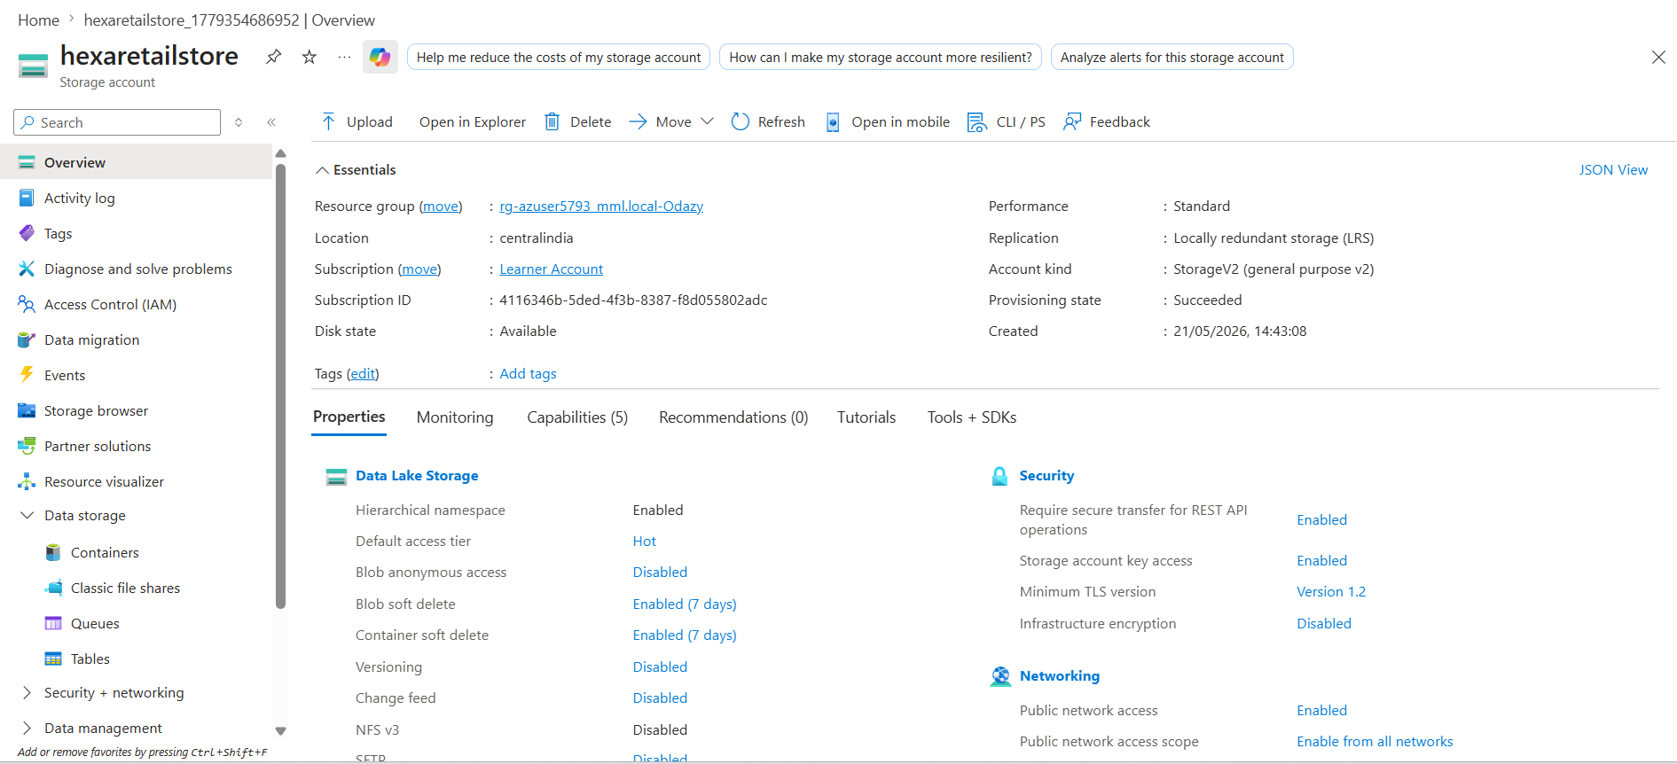
Create a container named retail-data.
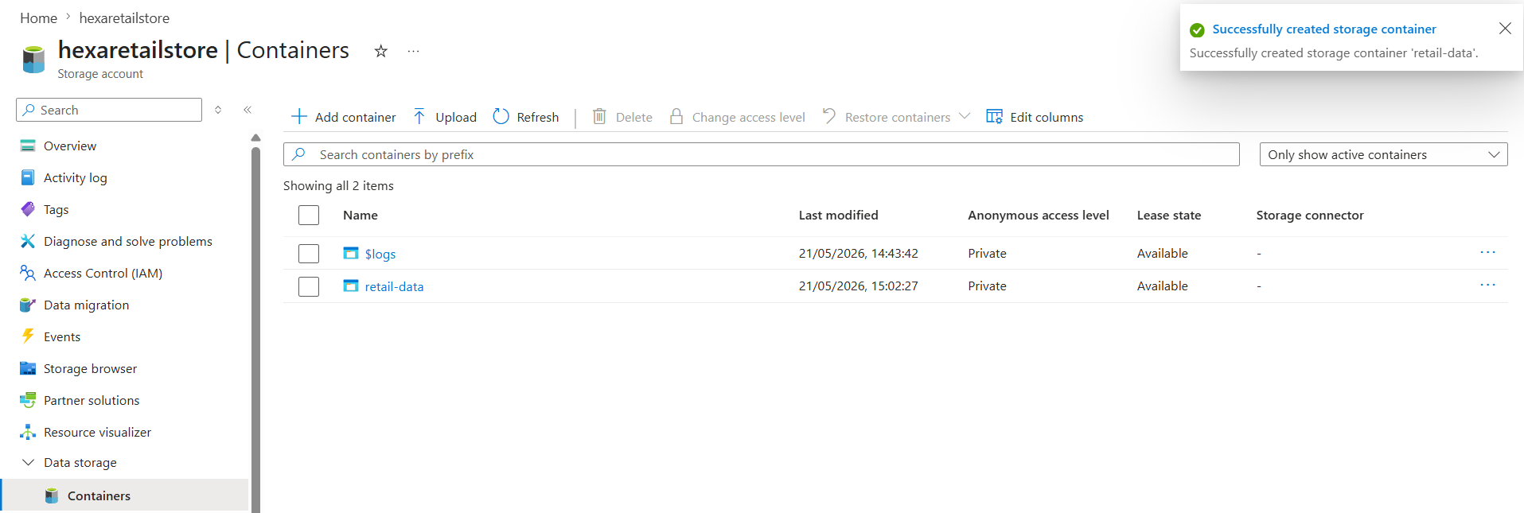
Inside the container, create this folder path:
raw/orders/
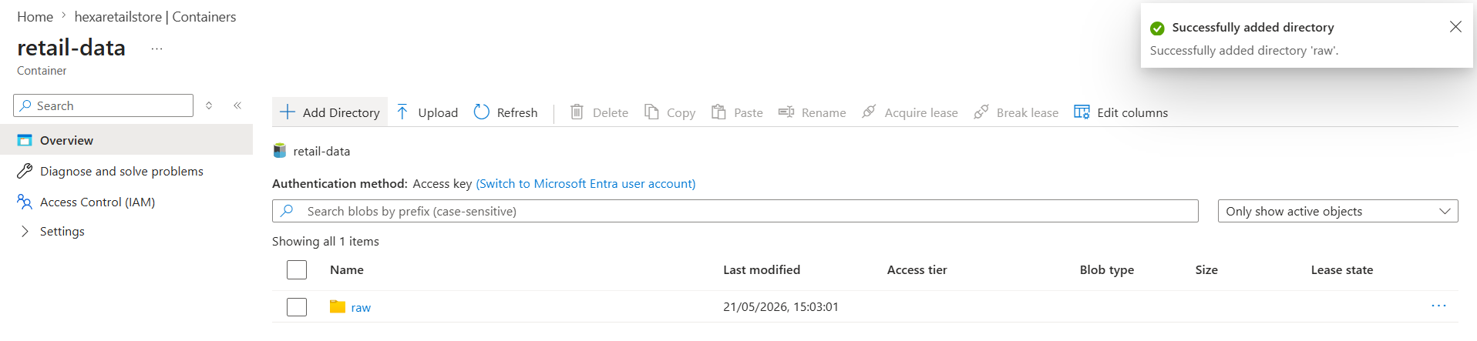
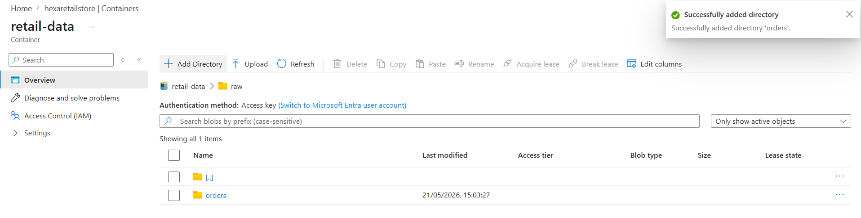
Upload the initial CSV file:
retail_orders_initial.csv
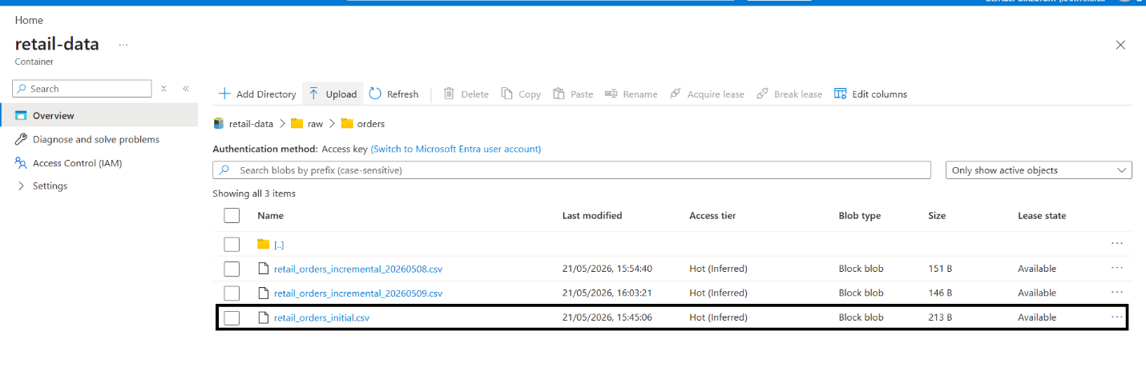
Part C: Snowflake External Stage

Create a file format for CSV.
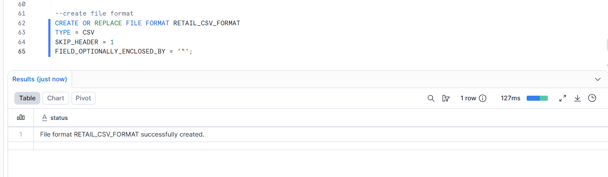
Create an Azure storage integration or external stage.
Create an external stage pointing to:
azure://<storage_account>.blob.core.windows.net/retail-data/raw/orders/
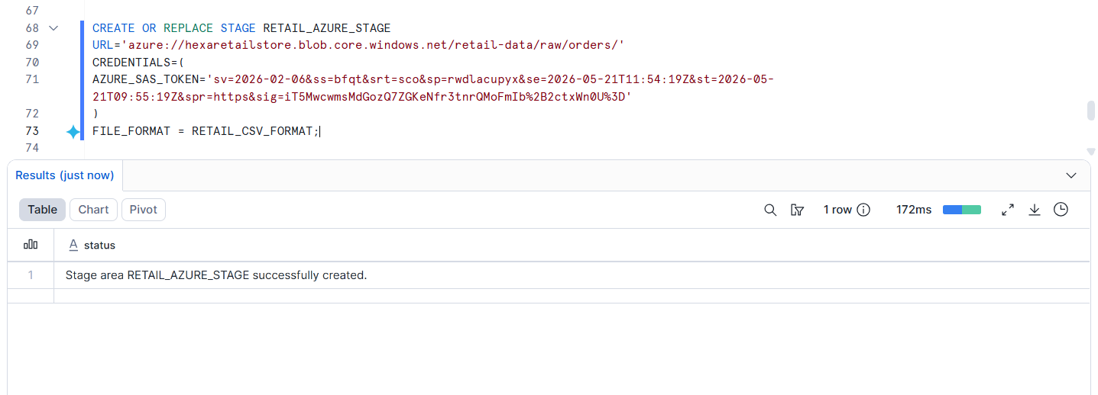
List files from the stage.
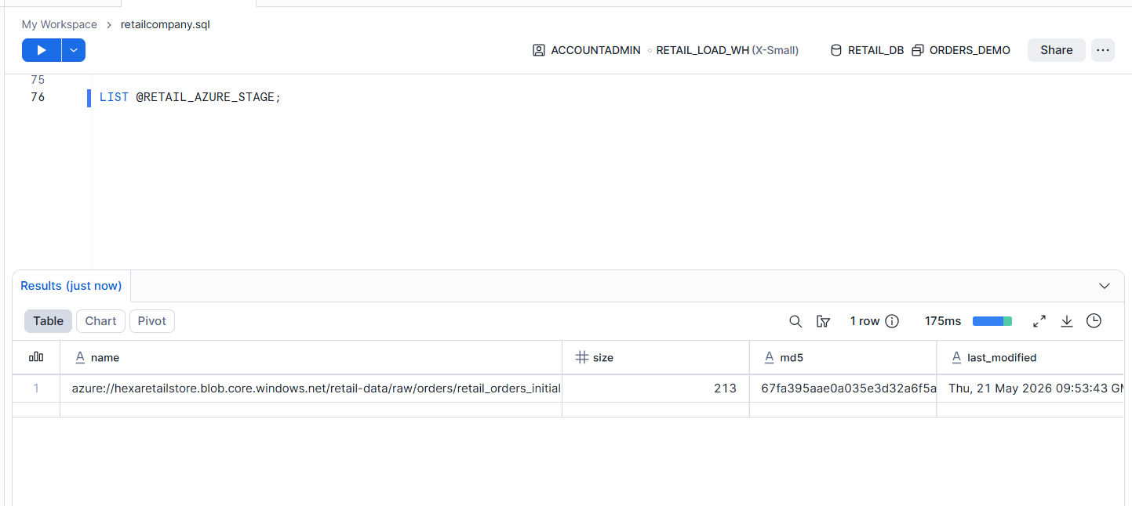
Part D: Initial Data Load

Create a raw landing table named ORDERS_RAW.
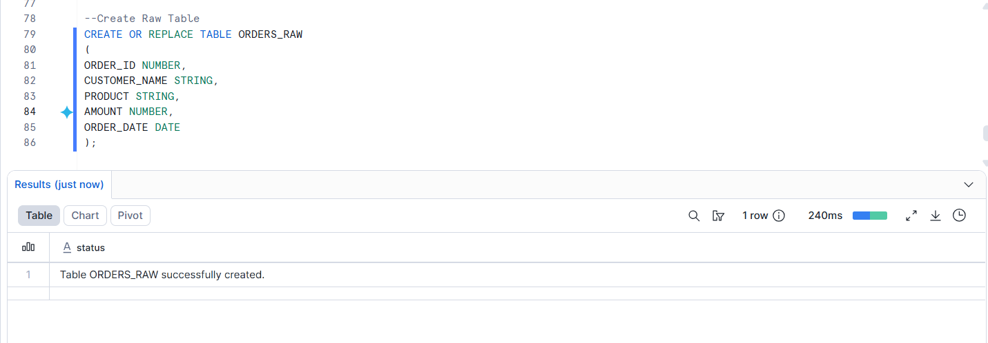
Create a final table named ORDERS_FINAL.
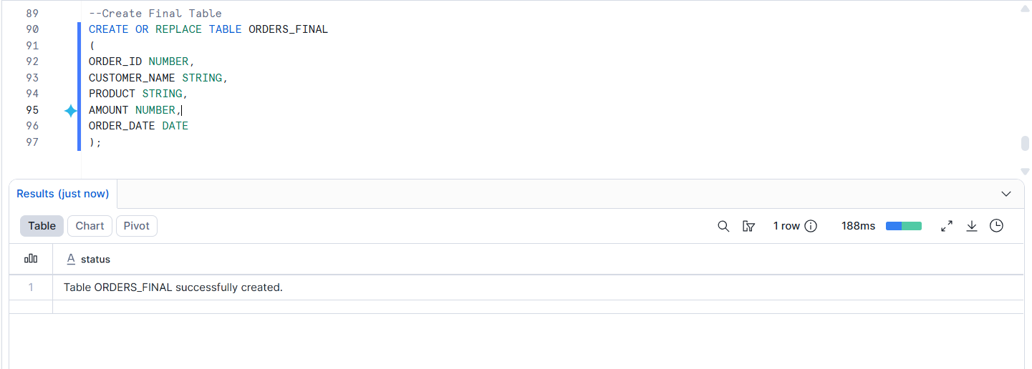
Load the initial file into ORDERS_RAW.
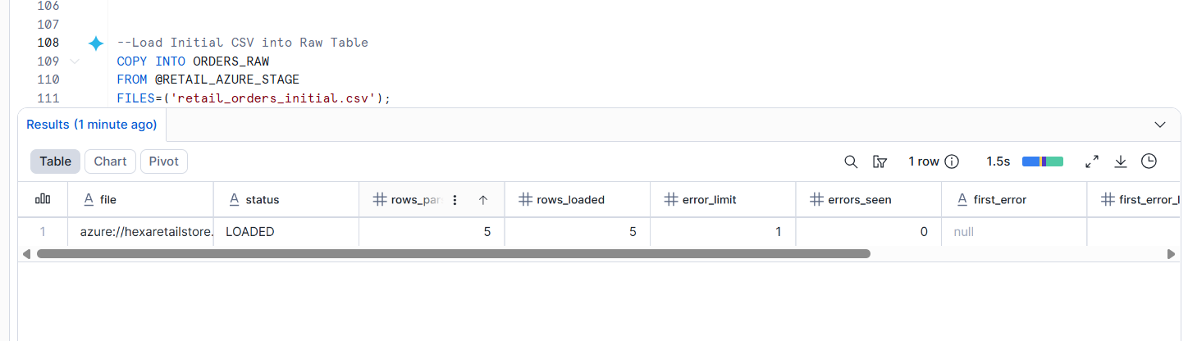
Insert data into ORDERS_FINAL.
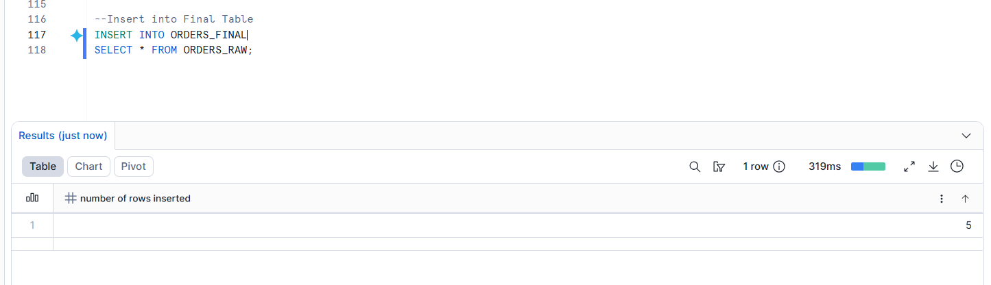
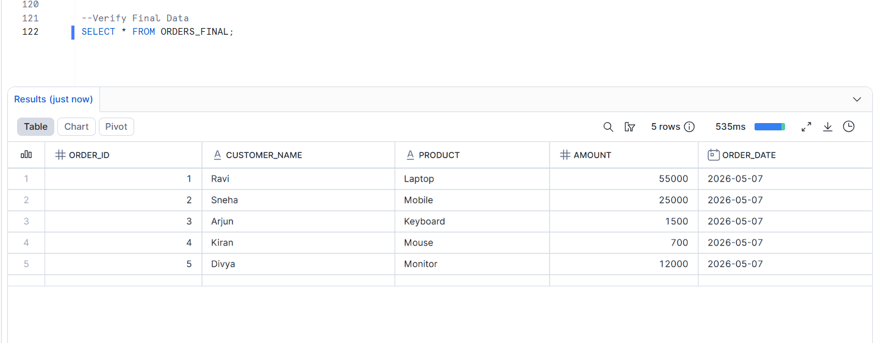

Part E: Incremental Loading

Create a Snowpipe object to load new files automatically into ORDERS_RAW.
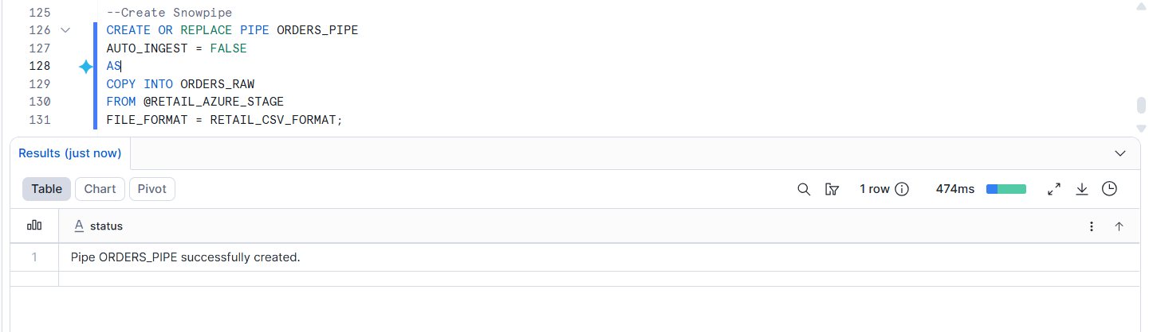
Create a stream on ORDERS_RAW.
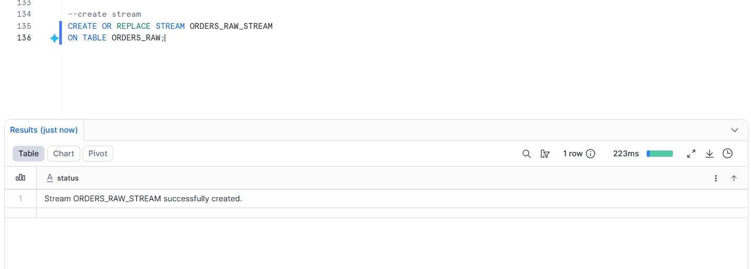
Create a task to merge new rows from the stream into ORDERS_FINAL.
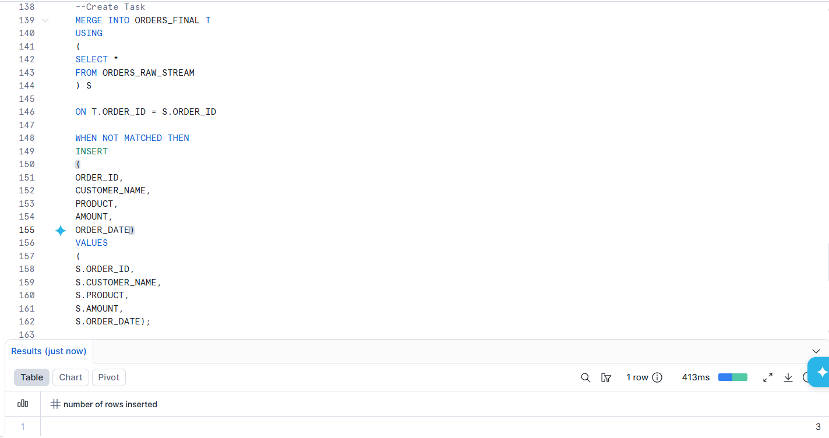
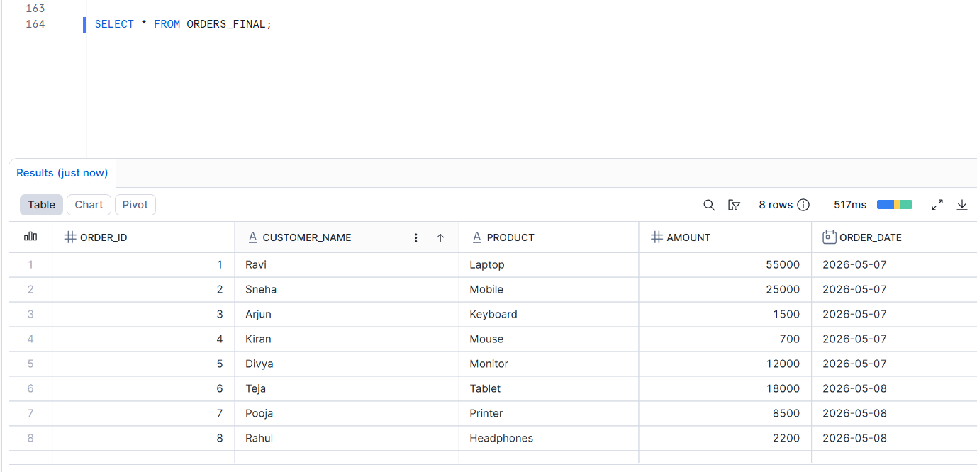
Upload another CSV file into Azure Storage.
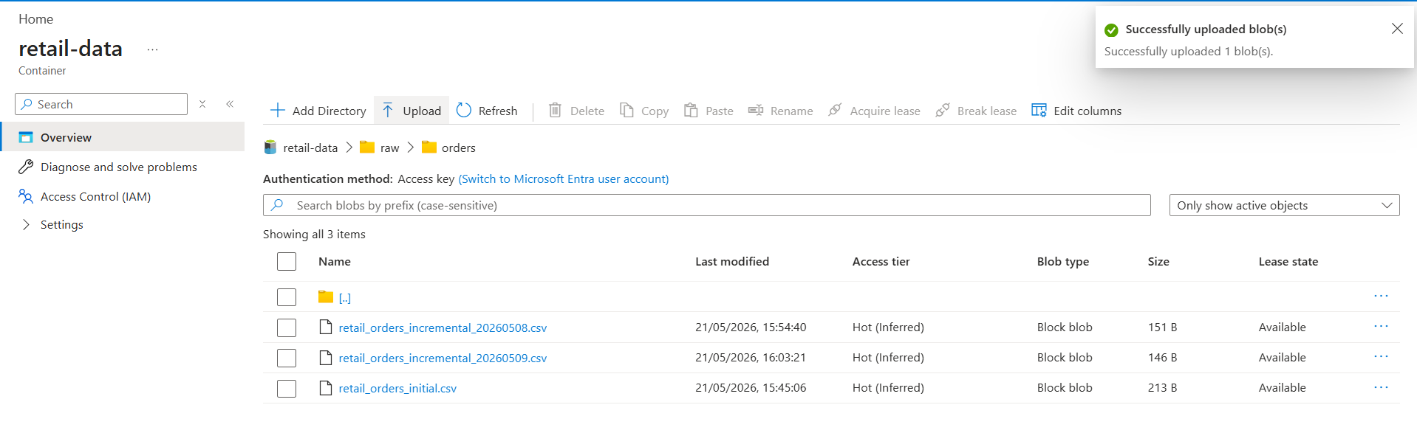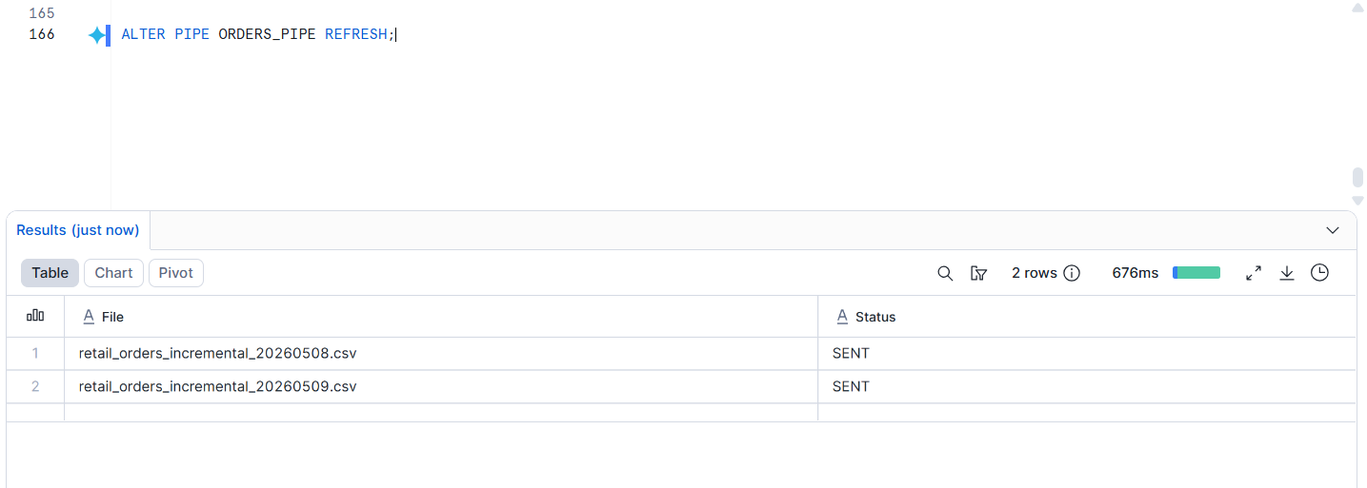
Verify that new rows are automatically loaded into Snowflake.

